
School Address: 923 South 9th Street, Midlothian, Texas 76065
Russell Wagner, LAT Russell.Wagner@midlohtianisd.org
Ashlyn Powell, MSAT, LAT, ATC Ashlyn.Powell@midlothianisd.org
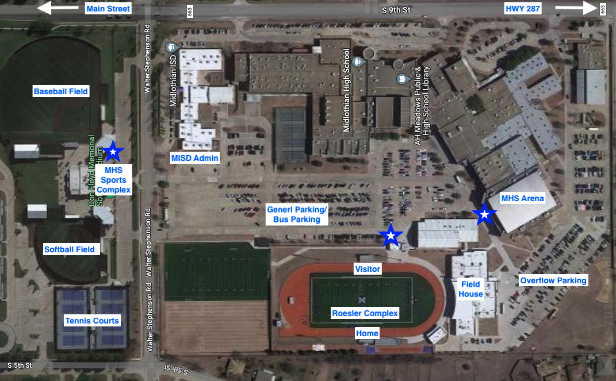

“Blue/White Star” designates main entrance to facility

Events at Arena
Access to a satellite athletic training room (treatment & taping tables, ice machine, water). We will provide coolers of ice water at each bench. AED is located just outside the northeast gym floor entrance.

Events at WG Roesler Complex
If you let us know that you are coming we may be able to reserve a good parking spot for you right at the entrance gate. The athletic training room and garage is located at the northwest corner of the fieldhouse. From there you can get access to treatment & taping tables, AED, ice machines, water. The only water access is located by the training room. For MHS hosted events, water will be set up for visiting teams.

Events at MHS Sports Complex
There is easy water access in all four dugouts. There is an AED on the wall next to the concession stand. For MHS hosted events, water will be set up for visiting teams.

